

*SMART STAR EXAMINATIONS BOARD*

*PRIMARY FIVE*

*INTEGRATED SCIENCE*

*LESSON NOTES*

*TERM II*

*2024*

**TERM II**

1. Components of the environment soil
2. Heat energy
3. Occupants in our community, crop growing
4. Bacteria and Fungi

**COMPONENTS OF THE ENVIRONMENT:**

***WEEK 1***

***LESSON 1***

**SOIL**

Soil is a continuous layer that covers the earth’s surface.

Or

Soil is a medium in which plants grow and get water and mineral salts.

**HOW SOIL IS FORMED**

* + By weathering
  + By decomposition of organic matter.

**Weathering** is the physical and chemical breakdown of rocks into small particles to form soil.

**Decomposition** is the rotting of dead organic matter.

**TYPES OF SOIL**

There are three types of soil

1. Clay soil.
2. Loam soil.
3. Sandy soil.
4. **CLAY SOIL**

**Characteristics of clay soil**

**-** It has fine particles.

- It has closely packed particles.

- It does not allow water to pass through it very fast.

- It has a high water retention capacity so it easily becomes water logged.

**-** Clay soil has the highest rate of capillarity

**Importance of clay soil**

* + Clay soil is good for pottery work (making pots, ceramics and modeling).
  + Clay soil is good for making bricks for building.
  + Clay soil is good for making tiles for roofing.

**Illustration of arrangement of particles in clay soil.**

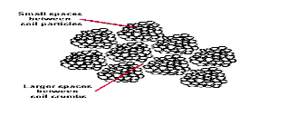

Activity

* 1. What is soil?
  2. Identify any three components of soil.
  3. How is soil formed?
  4. Mention the three types of soil.
  5. How is clay useful to man?

***LESSON 2***

1. **LOAM SOIL**

Loam soil is a mixture of clay soil and organic matter

Organic matter (humus) consists of decayed plants and animal matter

Loam soil usually has adequate water, air and humus to sustain plant growth.

**Characteristics of loam soil.**

- It’s particles are fairly arranged

- It contains both clay and sand particles.

- It has a lot of humus for plant growth.

- Has fairly larger air spaces as compared to clay soil

**Importance of loam soil**

* + It is good for crop growing.

**Illustration of arrangement of particles in loam soil.**

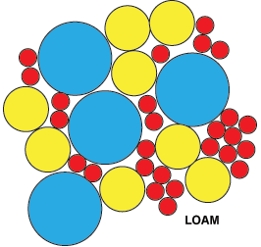

1. Why is loam soil the best for plant growth?

* **It contains a lot of humus.**

1. **It contains balanced particles of sand and clay.**
2. **SANDY SOIL**

**Illustration of arrangement of particles in sandy soil.**

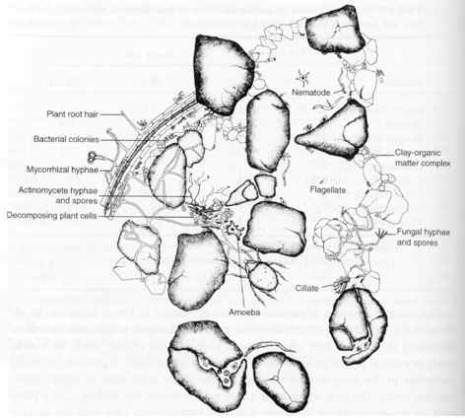

- Has large particles that make it to be well aerated

- Water passes through it easily

- Has poor water retention capacity

- Has high water drainage

- It is easy to dig

- Has a poor rate of capillarity

**Capillarity** is the up take of water through the soil particles. /

**Capillarity** is the tendency of water to rise through small narrow spaces.

**Drainage** is the capacity of the soil to allow water to pass through it.

**Importance of sandy soil.**

* Used for building.
* Used for making glass and sand papers.

Nb.It is not good for crop growing because it has a low water holding capacity.

**Activity**

1. why is loam soil the best for crop growing?
2. mention one characteristic of loam soil
3. identify the type of soil which used for making glass.
4. what is capillarity?
5. which type of soil is porous?

***LESSON 3***

**COMPONENTS OF THE SOIL**

These are things which make up soil, they include:

- Air.

- water

- humus

- rock particles

- living organisms eg bacteria, insects, earthworms etc.

**Importance of components of soil**

1. **Air**

- Air is used by animals in the soil to respiration.

- Air is used during germination.

1. **Water**

- Water is used by plants for germination

- Making starch (it is a raw material for photosynthesis)

- Promoting decay of matter

1. **Rock particles ( inorganic materials like: sand, gravels, clay formed by weathering)**

- Provide space for air to occupy

1. **Humus – dead decayed plants and animal matter**

- Provide plant nutrients.

- Improve soil fertility

- Makes the soil appear dark in colour

1. **Living organisms**

**Examples of animals that live in the soil.**

Bacteria, moles, porcupines, earth worms and ants

- Bacteria like nitrogen fixing bacteria fix nitrogen in the soil and hence improving on soil fertility.

**Earthworms**

* Aerate the soil.
* Softens the soil /plough the soil
* Add soil fertility by breaking down dead plants and animal remains.

**NB**: Why do you think earthworms come out of the soil after raining?

* To breathe /take in oxygen.

**PROPERTIES OF SOIL**.

* It has air.
* It has water.
* It contains mineral salts.
* EXPERIMENT ABOUT SOIL CONTAINS AIR.

**SOIL PROFILE**

Is the vertical arrangement of soil layers.

**Or**

Arrangement of soil layers from top to bottom.

**Areas where one can clearly see soil profile.**

- Pit latrines. – In trenches.

**Illustration of the layers of the soil.**

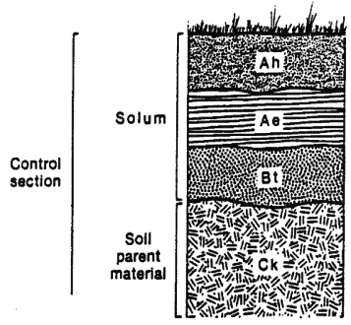

**Importance of the top most layer.**

- It contains most of the nutrients for plant growth.

**Briefly explain the following terms.**

* **Soil texture.** These are the different sizes of soil particles in an area.
* **Soil structure.** I the way soil particles are grouped/ arranged.

***Activity***

1. **What is soil profile?**
2. **Name the soil layer which good for plant growth.**
3. **Suggest any place where one can clearly soil profile.**
4. **What is soil texture?**
5. **Name any two organisms found in the soil.**

**LESSON 4 &5**

**SOIL EROSION**

Is the washing away of top soil by its agents?

**AGENTS OF SOIL EROSION**

These are forces that carry away top soil from one place to another. These include:

* Running water
* Wind
* Animals

**CAUSES OF SOIL EROSION**

These are main activities that enable the agents to take away top soil.

How?

* They expose the soil to agents

These include

* Deforestation
* Overgrazing

- bush burning

* Monoculture (mono-cropping)
* Ploughing down slopes.
* Over cultivation.

**TYPES OF SOIL EROSION**

* 1. Sheet erosion: Top soil is washed away uniformly by running water
  2. Gulley erosion (deep channels)
  3. Rill erosion (shallow channels)
  4. Splash erosion /raindrop erosion
  5. Stream /river bank erosion
  6. Wind erosion

**Effects of soil erosion.**

- Leads to soil exhaustion.

- It affects soil texture

**PREVENTION AND CONTROL OF SOIL EROSION.**

1. **Terracing:** reduces the speed of running water
2. **Strip cropping**: reduces the speed of running water
3. **Contour ploughing**: is the ploughing across a slope.

It helps to reduces the speed of running water

1. **Afforestation**: is planting of trees where they have ever existed. This also keeps the soil covered from direct rain drops.
2. **Re-afforestation**: is the planting of trees where they have been ever existed. This also keeps the soil covered from direct rain drops.
3. **Cover cropping**: planting cover crops between plants that take long to mature.

**Cover crops**

These are crops that are planted between plants that take long to mature

**Qn:** How does cover cropping prevent soil erosion?

Cover crops reduce the speed of running water

**Qn**: How does inter-cropping reduce soil erosion?

Reduces the speed of running water

1. **Bush fallowing:** resting period of land to regain its fertility

**Importance:** enables the land to regain its fertility

1. **Mulching:** is the covering of top soil with any plant material (dry plant materials)

**Advantages of mulching.**

- Controls soil erosion. **How?**By reducing the speed of running water.

- Maintains soil fertility.**How?**by reducing soil erosion and mulches rot to from humus.

- Keeps water in the soil.**How?**by controlling the rate evaporation of water from the soil.

- Increases on the crop yields.

- Reduces the rapid growth of the weeds.

**Disadvantages of mulching**

- Mulches keep pests.

- Dry mulches can be fire hazards.

- Some mulches can grow into weeds.

**How soil loses its fertility**

Through:

- Leaching. It is the sinking of plant nutrients deeper into the soil where plant roots can’t reach.

- Soil erosion

- Monoculture (mono-culture)

- Bush burning

**How can we improve soil fertility?**

- Mulching

- Crop rotation

- Bush fallowing

- Addition of fertilizers

- By terracing

- A forestation

**Activity**

**1. What is soil erosion?**

1. **Mention the three agents of soil erosion.**
2. **give any three causes of soil erosion**
3. **Name two types of soil erosion.**
4. **Identify any one effect of soil erosion.**

WEEK2

**Lesson 1&2**

**FERTILISERS.**

These are substances put in the soil to increase it’s fertility.

**Types fertilizer**

- Artificial fertilizers.

- Natural fertilizers.

**ARTIFICIAL FERTILIZERS**

Are fertilizers got from inorganic matter artificially.

**Types of artificial fertilizers**

- Straight fertilizers.

- Compound fertilizers.

**Straight fertilizers.**

These are fertilizers that supply one nutrient to the soil.

**Examples:** SSP (single supper phosphate), nitrogen, phosphorus, potassium.

**Compound fertilizers.**

These are fertilizers that supply more than one nutrient to the soil.

**Examples:** dramonium phosphate, NPK.

**Advantages of using artificial fertilizers**

* They have a high nutrient content needed by the plants.
* They are easy to handle, use and store.
* They help to make plants resistant to diseases as they grow.
* They provide the needed minerals with out fail.
* They supply a large quantity of mineral salts.
* They provide freedom of choice to farmers as they buy the type that they need.
* They improve crop yield.
* They supply the correct a mount of mineral salts to soil to meet the requirement of crops.

**Disadvantages of using artificial fertilizers**

- They are expensive to buy.

-They require skilled labour to apply it.

- They stay in the soil for a shorter period.

- They are poisonous to animals, people and birds.

- They pollute water sources when washed there.

- They destroy soil texture and structure.

- They make the soil acidic.

- They kill organisms in the soil.

**Natural fertilizers (manure)**

These are fertilizers made from decayed plant and animal materials[ humus)

**Types of natural fertilizers (manure)**

There are four types of manure

1. Compost manure

2. Green manure

3. Farm yard manure

4. Organic mulch.

**ACTIVITY**

* 1. What are fertilizers?
  2. Name the two types of fertilizers.
  3. Write in full SSP.
  4. A part from straight fertilizer, mention another type of artificial fertilizer.

**LESSON 3&4**

**Compost manure**

Is got from both plant and organic waste matter left to decay.

**Things used to make compost manure.**

- banana peeling.

- dry grass

- maize stalks

- leaves.

**COMPOST HEAP.**

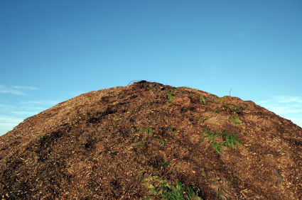

**Importance of compost manure**

- Adds humus to the soil (improves soil fertility)

- Controls leaching

- Improves soil structure

**Advantages of compost manure**

* It is cheap.
* Its nutrients last for a longer time
* It is not poisonous to people, animals and birds
* It does not require skilled labour to apply it.
* Provides many nutrients to the soil at the same time.

Nb: When making compost manure, water should be added to the compost heap to make the rotting faster.

**Disadvantages of compost manure**

* Produces bad smell
* It takes a lot of space
* Soil nutrients take long to be released into the soil
* It is not easy to tell which nutrients is present in the compost manure

**Green manure**

It is made from green crops especially legumes that are ploughed back into the soil at the flowering stage.

Why legumes? They can rot in a shorter time.

**Advantages of green manure**

* It lasts for several seasons in the soil.
* It rots and mixes easily into the soil.
* Its nutrients last for a longer time
* It is not poisonous to people, animals and birds
* It does not require skilled labour to apply it.

**Disadvantages of green manure**

* It is time wasting.
* It requires a lot of labour to plough it back into the soil.
* It is not easy to tell which nutrient is present in the green manure.

**Farm yard manure**

Is the manure got from animal wastes like dung and urine mixed with their bedding materials?

**Advantages of farm yard manure**

* It is cheap
* Its nutrients last for a longer time
* It is not poisonous to people, animals and birds
* It does not require skilled labour to apply it.
* Provides many nutrients to the soil at the same time

**Disadvantages of farm yard manure**

* It contains little amount of mineral salts.
* Produces bad smell
* It takes a lot of space
* Soil nutrients take long to be released into the soil
* It is not easy to tell which nutrient is present in the compost manure.

**Effects of harmful materials on the soil**

* Non degradable materials do not rot or decay
* They prevent or block air and water from entering the soil
* They lead to soil exhaustion.

**These materials are called pollutants**

**Examples of soil pollutants.**

* Polythene papers (buveera)
* Plastic materials
* Rubber materials (old shoes)
* Glass and broken bottles
* Metallic materials like nails, tins, etc
* Concrete from broken buildings.

**Ways of properly handling wastes.**

* Reusing plastic materials like jerry cans for other purposes like fetching water.
* Making new things from some wastes (recycle)
* Returning some wastes like bottles to the factories that make sodas.
* Rejecting/ refusing the use of non biodegradable materials like polythene bags.
* Reducing on the production of non biodegradable materials.

**ACTIVITY**

* 1. **What is compost manure?**
  2. **State two advantages of compost manure.**
  3. **Suggest any two disadvantages of green manure.**
  4. **What are soil pollutants?**
  5. **Give two examples of soil pollutants.**

**LESSON 5&6**

**SOIL BARRIERS**

These are things (materials) that prevent soil from being carried away by the agents of soil erosion.

**Examples of soil barriers**

* Grass ( cover crops)
* Trees /roots
* Rocks
* Concrete walls
* Contours
* Gabions. Etc

**SOIL CONSERVATION**

Is the maintaining (preserving) of soil fertility.

**Methods of soil conservation**

* Afforestation /re-afforestation
* Bush fallowing
* Terracing hilly areas
* Rotational grazing
* Contour ploughing
* Strip cropping
* Crop rotation
* Mulching
* Cover cropping
* Mixed farming
* Manuring /application of the fertilizers
* Agro-forestry.

**Importance of soil conservation**

* Retains soil fertility
* Retains soil moisture
* Prevents spread of diseases and pests.

ACTIVITY

1. What are soil barriers?
2. give any four examples of soil barriers
3. What is mulching?
4. State any two advantages and disadvantages of mulching.

**WEEK 3**

**LESSON 1 & 2**

**FORMS OF ENERGY**

Energy is the body’s ability to do work

**Matter**

Matter is anything that has mass and volume

**OR**anything that has weight and occupies space

The meaning of each of the following

* 1. **Mass: is a quantity of matter in an object.**
  2. **Volume:** Is the space occupied by an object.

c. **Molecules:** It is the smallest particles of matter.

**d. Weight:** is the gravitational force exerted on an object by the earth.

**States of matter**

**There are three different states of matter**

- Solids

- Liquids

- Gases

**Solids**

**Examples of solids.**

**-** Wood

- Rubber

- Glass

- Plastic

**Characteristics of solids.**

- Molecules are closely packed.

- Particles are held together very tightly.

- Molecules do not move from position but vibrate.

- Solids have shape, size and volume apart from irregular objects.

**Diagram to show the arrangement of molecules.**

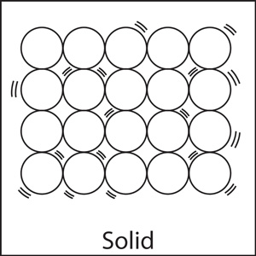

**Liquids**

**Examples of liquids.**

- Water

- Soda

- Oils

- Juice

**Characteristics of liquids.**

- Molecules are spaced.

- Molecules loosely held together.

- Liquids have a proper volume (capacity)

- Liquids have no definite shape (take up the shape of the container in which they are poured)

**Diagram to show the arrangement of molecules.**

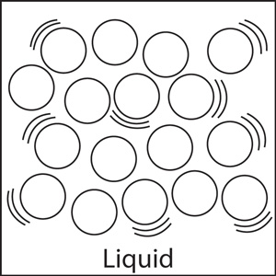

**Gases**

**Examples of gases.**

- Nitrogen

- Carbon dioxide

- Oxygen

- Rare gases

**Characteristics of gases.**

- Molecules are far apart

- Gases have no definite shape

- Gases have a particular volume.

- Molecules move freely.

**Diagram to show the arrangement of molecules.**

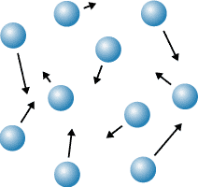

**ACTIVITY**

1. **what is energy?**
2. **what is matter?**
3. **name the three states of matter.**
4. **in which state of matter are the following**
   1. **water**
   2. **metal**
   3. **oxygen**

**LESSON3&4**

**ENERGY**

Energy is ability to do work

F**orms of energy.**

- Heat energy

- Sound energy

- Light energy

- Sound energy

- Electric energy

- Magnetic energy

- Chemical energy

- Solar energy.

**Types of energy**

- Kinetic energy

- Potential energy

**Potential energy**

Is the energy that is stored by an object at rest.

**Examples of potential energy**

- A baby being asleep in a cot

- A car standing still at traffic lights

- A pupil sitting and listening to the teacher

- A stone / book ruler resting on a table /ground /cupboard etc

**Kinetic energy**

This is the energy possessed by a moving object or an object in motion. It is also referred to as the energy in motion

**Examples of kinetic energy**

- A girl running along the road

- An arrow flying through the air

- A stone thrown up in air

- A brick dropping from a wall

- A leaf falling to the ground from a tree

**Think of a stone or a pendulum swinging in air**

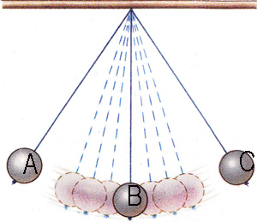

At A, the stone possess potential energy

At B, the stone possess kinetic energy

**Activity**

1. Mention the two types of energy.
2. Define the following types of energy
   1. potential energy.
   2. kinetic energy.
3. List down any three forms of energy.

**LESSON 5&6**

**HEAT ENERGY**

Heat energy is a form of energy that increases temperature of an object

**Standard units for measuring heat.**

Heat **Calories**

**Instruments used to measure heat**.

Heat **Calorimeter**

**sources of heat**

These are objects that produce heat.

**Types of sources of heat.**

* 1. Natural sources of heat
  2. Artificial sources of heat

**Natural sources**

Natural sources of heat provided by nature.

Examples.

- Sun (main natural source of heat)

- Food

- Stars

- Erupting volcanoes

**Artificial sources.**

These are sources of heat made by people.

**Examples of artificial sources of heat.**

- Lamps

- Bulbs

- Candles

**Uses of heat to man**

- used for ironing clothes

- Heat is used to run some machines e.g. steam engines. Diesel engines, rockets etc.

- used to dry harvested crops before storage.

- Heat evaporates the water in water bodies and plants during rain formation

- Heat enables us to cook our food

- Heat can act as a disinfectant.

**Effects of heat on matter**

Heat causes the following effects to matter.

* Melting.
* Expansion.
* Evaporation.
* Sublimation.

**Diagram to show physical changes of state of matter.**

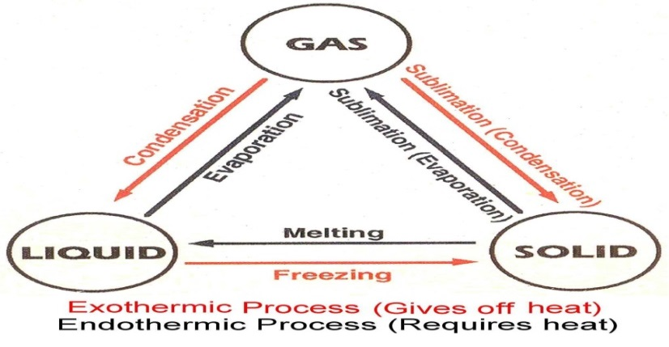

**A -** Melting physical change from solid to liquid

**B -** Evaporation physical change from liquid to gas.

**C -** Freezing physical change from liquid to solid.

**D -** Condensation – Physical change from gas to liquid

**E -** Sublimation physical change from solid to gas.

**F -** Sublimation physical change from gas to solid.

**ACTIVITY**

1. **What is heat energy?**
2. **Name two the types of sources of heat in the environment.**
3. **Give two examples of each of the following sources of heat**
   1. **Natural source of heat.**
   2. **Artificial source of heat.**
4. **Identify any two effects of heat on a state of matter.**

**WEEK4**

**LESSON 1&2**

**EFFECTS OF HEAT ON EACH STATE OF MATTER.**

**SOLIDS.**

- Metals expand.

**Metallic ball ring experiment**

a). Before heating the metallic ball goes through the ring.

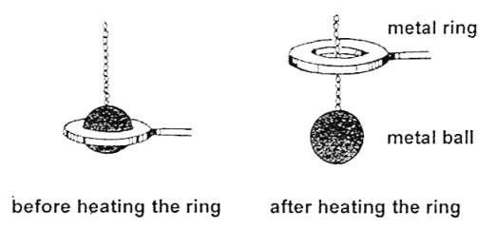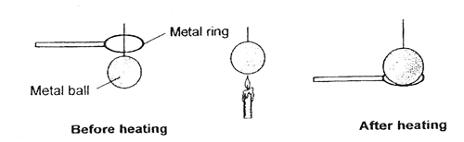

b). after heating the metallic ball does not pass through the ring

**Reasons why metallic ball did not go through the ring after heating**

The metallic ball had expanded

**Conclusion**

Metals expand when heated

**LESSON 3&4**

**What do you think can happen to the metallic ball if dipped into cold water?**

The hot metallic ball will contract and pass through the ring again.

**Bimetallic strip.**

Before heating and after heating

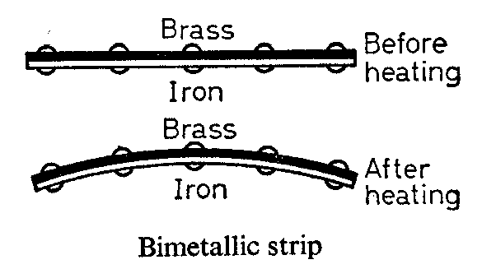

**Observation**

The iron strip heats up and expands faster than the copper strip hence bending to wards the copper.

**Qn: 1.** which of the two metals is the best conductor of heat?

**IMPORTANCE OF A Bimetallic.**

* Bimetallic strips are used in automatic switches of electric kettles, flat irons, fridges, freezers etc.

**illustration of a railway line showing the gaps left during construction.**

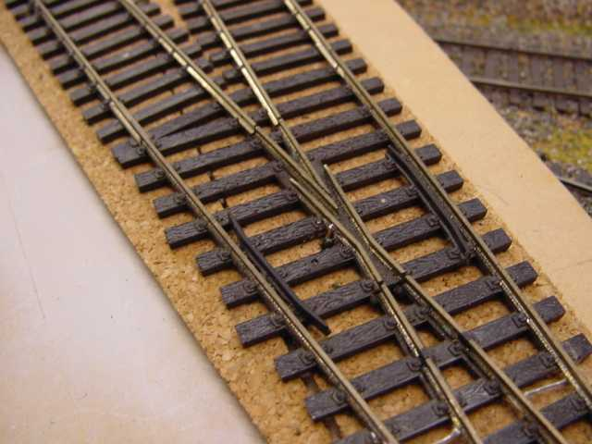

**Qn:** What happens if gaps were not left between rails during construction?

The rails would expand on hot days bend and cause railway accidents.

1. Why are gaps left between railways during construction?

To leave room for expansion on a hot day.

**Diagrams to show the effect of heat on electric / telephone wires**

**On a hot day.**

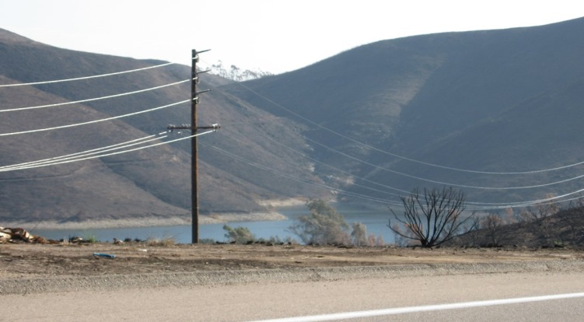

Electric / telephone wires expand become loose and starts sagging / slacking.

**On a cold day** wire contract and become shorter appearing relatively tight.

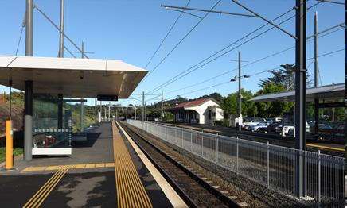

**Qn;** 1. Why are gaps left between electric / telephone wires during construction?

To allow room for expansion.

1. What would happen to the wires when tied tightly fixed on the poles?

The wires would break due to contraction on cold days

**Activity**

1. **Why gaps left between the railway lines during construction?**
2. **Whytelephone wires are loosely fixed on the poles?**
3. **what happens to electric wires on the following** 
   1. **Cold days.**
   2. **Hot days.**

**LESSON 5&6**

**EFFECTS OF HEAT ON ICE.**

**What happens to ice when heated?**

- Ice melts

- The volume decreases, the density increases and the mass remains the same.

**EFFECTS OF HEAT ON GASES**

What happens to gases when:-

a). Heated - Gases expand

b). Cooled - Gases contract

**EXPERIMENT TO SHOW THAT GASES EXPAND WHEN HEATED.**

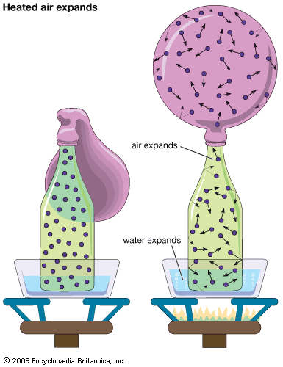

**QN:1.** Why does the balloon in diagram A expand?

Due to expansion of air inside the plastic bottle.

1. What happens to the balloon when the bottle is removed from the hot water?

The balloon collapses due to contraction of the air inside the plastic bottle.

**Effects of heat on liquids**

* Liquids expand when heated.
* Liquids evaporate when heated.

- Liquids contract when cooled

**Effects of freezing of liquids**

- Liquids increase in volume

- Liquids reduce in density

- Mass of liquids remains the same.

**Diagram to show that liquids expand when heated.**

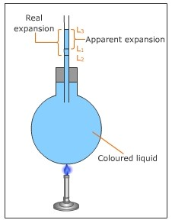

**Qn: 1.** why is space left while bottling drinks like soda?

To leave room for increase in volume when frozen.

1. Why is carbondioxide packed in bottled drinks like soda?

To preserve the soda.

A BOTTLE WITH THE SPACE LEFT

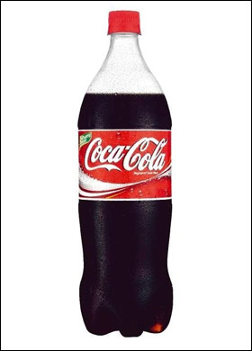

Space left to give room for

increase in volume on freezing.

**Effects of heat on sublimates**

**NB:** Sublimates are substances which can directly change from solid to gas.

**Examples of sublimates**

1. Iodine granules (crystals)
2. Ammonium chloride(salts)
3. Solid carbon dioxide.

**WEEK 5**

**LESSON 1&2**

**TEMPERATURE**

Is the degree of hotness or coldness of an object.

**Standard units for measuring temperature.**

Temperature **Degrees**

**Instrument used to measure temperature.**

Temperature **Thermometer**

**Thermometer**

Thermometer is an instrument used to measure temperature.

**The following thermometer measure the following:-**

- Lowest temperature of the day **Minimum thermometer**

- Highest temperature of the day **Maximum thermometer**

- Room temperature or temperature of the air **Wall thermometer**

- Highest and lowest temperature of the day **Six’s thermometer**

- Human body temperature **Clinical thermometer**

**Places where we find clinical thermometer in daily life**

- In clinics

- In hospitals

- In dispensaries

Places or common sites on our bodies where a clinical thermometer can be placed while measuring the human body temperature

* Under the arm pits
* In the anus
* In the mouths / under the tongue

**Diagram of clinical thermometer**

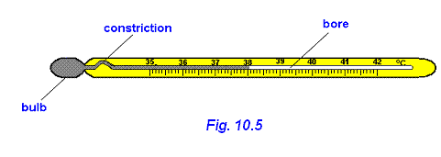

**Importance of each part**

**Stem:** Protects the inside parts of a thermometer

**Kink:** Prevents the back flow of mercury to the bulb before the actual temperature is taken.

**Bore:** The bore has a regular scale.

**Bulb:** The bulb store mercury.

**Liquids commonly used in thermometers.**

- Alcohol

**-**Mercury

**ACTIVITY**

1. **What is temperature?**
2. **State the difference between heat and temperature.**
3. **Name the any one type of thermometer.**
4. **Which liquids are used in the thermometers**

**LESSON 3**

**SIX’S THERMOMETER ( MINIMUM AND MAXMUM THERMOMETER)**

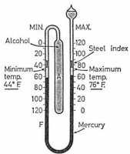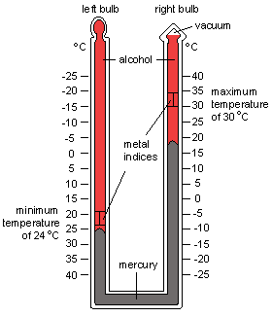

**Reasons why mercury is used in a thermometer**

- Mercury is a good conductor of heat

- Mercury does not stick on the walls of the bulb / bore.

- Mercury can easily be seen in the glass.

- Mercury has even and regular expansion.

**Reasons why water is not used in a clinical thermometer**

- Water is not easily seen

- Water is a bad conductor of heat

- Water needs a lot of heat to expand.

- Water’s does not expand uniformly.

**Why do doctors shake a clinical thermometer before using it on other patients?**

- To draw the mercury back to the bulb

**Reason why a clinical thermometer is sterilized using surgical spirit**

- Boiling it will make the stem expand and burst.

**The normal human body temperature**

- Celsius 370c.

- 98.6/ 98.4degrees Fahrenheit.

**LESSON 4**

**Changing from Celsius to Fahrenheit**

* 1. 200c

F = (c x 9) + 320

5

F0 = (~~20~~ x 9) + 32

~~5~~

F0 = (4 x 9) +32

F0 = 36 + 32

0F = 680

* 1. 250c

F = (c x 9) + 320

5

F0 = (~~25~~ x 9) + 32

~~5~~

F0 = (5 x 9) +32

F0 = 45 + 32

0F = 770

* 1. 50c

F = (c x 9) + 320

5

F0 = (~~5~~ x 9) + 32

~~5~~

F0 = (1 x 9) +32

F0 = 9 + 32

0F = 410

F = (c x 9) + 320

5

F0 = (~~0~~ x 9) + 32

~~5~~

F0 = (0 x 9) +32

F0 = 0 + 32

0F = 320

* 1. 800c

F = (c x 9) + 320

5

F0 = (~~80~~ x 9) + 32

~~5~~

F0 = (16 x 9) +32

F0 = 144 + 32

0F = 1760c

* 1. 1000c

F = (c x 9) + 320

5

F0 = (~~100~~ x 9) + 32

~~5~~

F0 = (20 x 9) +32

F0 = 180 + 32

0F = 2120

**ACTIVITY**

**Change the following from degrees Celsius to degrees Fahrenheit**

1. **5oc**
2. **100c**
3. **1000c**
4. **00c**
5. **80c**

**LESSON 5**

**Changing temperature from Fahrenheit to Celsius**

Example 410F to C0

C0 = (F – 32) x 5/9

C0 = (41 – 32) x 5/9

C0 = (410 – 32) x 5/9

C0 = ~~9~~ x 5/~~9~~

C0 = 1 x 5

C0 = 50

Change 680F to C0

C0 = (F – 32) x 5/9

C0 = (680 – 32) x 5/9

C0 = 36 x 5/9

C0 = 4 x 5

C0 = 200

Change 320F to C0

C0 = (F – 32) x 5/9

C0 = (320 – 32) x 5/9

C0 = 0 x 5/9

C0 = 0 x 5

C0 = 00

Change 590F to C0

C0 = (F – 32) x 5/9

C0 = (590 – 32) x 5/9

C0 = 27 x 5/9

C0 = 3 x 5

C0 = 150

Change 950F to C0

C0 = (F – 32) x 5/9

C0 = (950 – 32) x 5/9

C0 = 63 x 5/9

C0 = 7 x 5

C0 = 350

Change 770F to C0

C0 = (F – 32) x 5/9

C0 = (770 – 32) x 5/9

C0 = 45 x 5/9

C0 = 5 x 5

C**0 = 250**

**ACTIVITY**

**Change from Fahrenheit to Celsius**

1. **680c**
2. **320c**
3. **410c**
4. **770c**

**WEEK 6**

**Lesson 1&2**

**HEAT TRANSFER**

How heat travels through the states of matter

1. Solids by Conduction

2. Liquids by Convection

3. Gases by Convection

Vacuum by Radiation

**Vacuum**

A vacuum is a space without molecules.

**Importance of molecules in heat transfer**

* Molecule act as a medium of heat transfer.

**Qn: In** which state of matter does heat travel?

A) **Fastest –** gases

Why? The molecules in gaseous state move freely than in any other state of matter.

**Slowest –** Solids

Why? The molecules do not move freely.

**An illustration of heat transfer in solids**

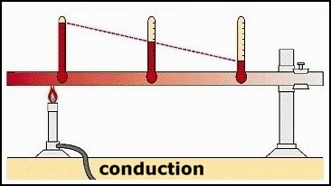

**Qn**: 1. how does heat move from point B to point A?

By conduction

1. Which of the above wax will melt first?

Wax 1.

**Reason:**  Wax 1 is nearest to the flame

1. Which of the above wax will melt last?

Wax 4

**Reason:**wax 4is furthest from the flame.

**Importance of heat transfer by conduction**

* Ironing our clothes using hot bodies like flat irons, iron boxes.
* Cooking food.
* Boiling water in a kettle.
* Welding or smelting metallic objects.
* Roasting meat using an iron rod.

**Diagram to show convection of heat**

1. **in gases.**

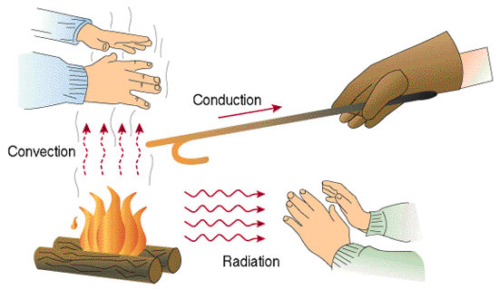

1. **liquids**

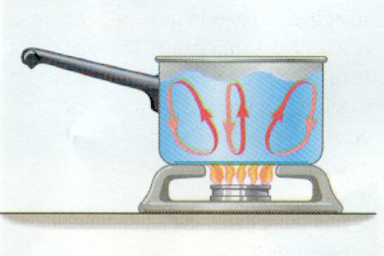

**Importance of convection in our daily life**

- helps smoke to move out of the kitchen through the chimney.

- Convection current helps in free circulation of fresh air in our houses.

- Convection currents help in formation of breezes.

- Taking of bad smell through the vent pipes of a VIP latrine**.**

**Importance of each of the following on a house.**

**1. Ventilators:** let out warm air

**2. Windows:** let in fresh air

**3. Doors:** let in fresh air

**ACTIVITY**

**1.** How does heat travel through the following

1. Solids?
2. Liquids?
3. Gases?
4. Vacuum?
5. in which state of matter does heat travel
6. fastest
7. slowest

**LESSON 3**

**SEA AND LAND BREEZE.**

**Sea breeze**.

It is when cool gentle current from the sea moves to the land to replace the warm risen air. It occurs during day.

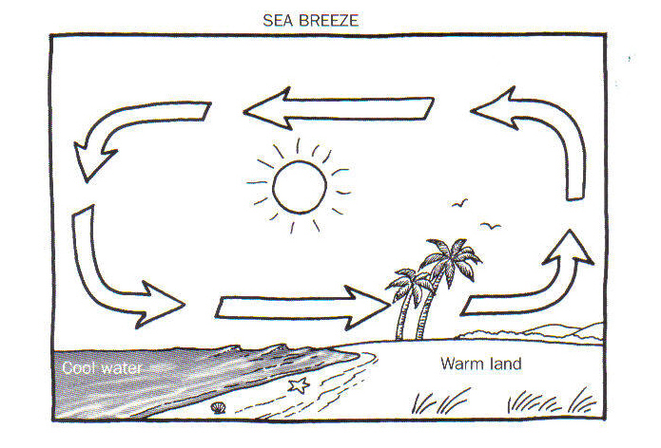

**land breezes.**

It is when cool gentle current from the land moves to the sea to replace the warm risen air. It occurs at night.

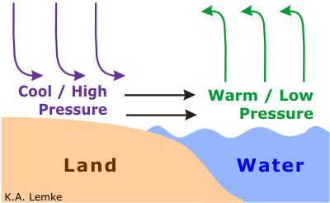

Nb: Sea breeze brings cool fresh air on land.

**LESSON 4&5**

**RADIATION.**

It is the process by which heat passes through a vacuum.

**QN:** How does a person standing in Namboole on sunny day receive heat from the sun?

By radiation.

**Importance of heat transfer by radiation in the environment**

* Radiation is used while roasting meat, fish or chicken in an oven.
* Warming our bodies using warmers or heaters.
* Dries harvested crops / wet clothes on wires.

**Reflectors and absorbers or heat.**

**Reflectors:** are shiny surface that reflect heat and light

**Absorbers:** are dull / black surface that absorb heat and light.

**Examples of reflectors**

- Mirrors

- Glasses

**Absorbers**

- Black clothes

- Black cars

Why are most houses, vehicles and fridges in most tropical countries like Uganda painted white? **To reflect heat**

If John washed a black and a white shirt and spread under sunshine;

* 1. Which shirt would dry first? **The black shirt.**

**Reason:** Black absorbs a lot of heat.

**Last?** The white shirt

**Reason:** The white shirt would reflect heat.

**Conductors and insulators of heat**

Good conductors: - are materials which allow heat to pass through them easily.

**Examples of good conductors of heat**

1. Iron
2. Mercury
3. Aluminum
4. Brass
5. Zinc
6. Copper
7. Silver
8. Lead

**Insulators of heat**

Insulators are the materials which don’t allow heat to pass through them easily.

**OR**

Insulators are bad (poor) conductors of heat

**Examples of bad conductors of heat**

1. Distilled Water
2. Rubber
3. Plastic
4. Paper
5. Cotton wool
6. Cloth
7. Sponges.

**ACTIVITY**

* 1. **How does heat from the sun reach people on earth?**
  2. **State two importance of heat transfer by radiation in the environment.**
  3. **What are insulators?**
  4. **Give four examples of insulators.**

**Experiment to show that water is a poor conductor of heat**

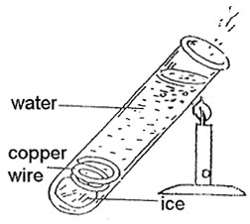

**Observation**

* Ice did not melt
* The water will boil at the area being heated while the ice cubes at the bottom will remain unmelted.

**Use of conductors**

* Used to make saucepans
* Used to make kettles
* Used to make bottoms of iron boxes

**Insulators**

* Paper is used to make cards
* Cloth keeps us warm
* Cork prevents heat loss in a vacuum flask.
* Why are handles of iron boxes, frying pans, flat irons made of wood, rubber / plastics?

To prevent the user from getting burnt.

**LESSON 6**

**A VACUUM FLASK (THERMOMETER FLASK)**

A vacuum flask keeps hot things hot and cold things cold.

**A DIAGRAM OF A VACUUM FLASK**

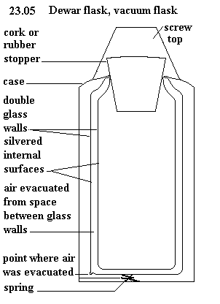

**Uses of each part of a vacuum flask**

**Cork:** Prevents heat loss or gain by conduction.

**Silvered surfaces:** prevents heat loss or gain by radiation (a good reflect of heat).

**Vacuum:**  Prevents heat loss or gain by both conduction and convection.

**Felt (cork base):**  Absorbs shocks to prevent the glass from breaking.

Felt are also poor conductors of heat.

**Vacuum seal:** Prevents matter form entering the vacuum.

**ACTIVITY**

* 1. **Of what importance is the thermos flask at home?**
  2. **Why is a vacuum seal important in thermos flask?**
  3. **What is the use of the cork on the vacuum flask?**
  4. **Why are the walls of a vacuum flask double silvered?**

**WEEK 7**

**LESSON 1, 2 & 3**

**OCCUPATIONS IN OUR COMMUNITY: CROP GROWING**

**CROP GROWING**

**ROOT CROPS**

Root crops are crops that store their food in the swollen underground roots.

**Examples of root crops**

* Cassava
* Sweet potatoes
* Carrots
* Yams

**STEM TUBERS**

Are crops which store their food in swollen underground stems.

**Examples of stem tubers**

* Coco yams
* Irish potatoes

Which food values do we get from eating mostly root crops.

We get carbohydrates.

**How are the following crops propagated?**

|  |  |
| --- | --- |
| **Crop** | **Propagation** |
| Cassava | By planting stem cuttings |
| Sweet potatoes | By planting vines / stem cuttings |
| Carrots | By planting carrot seeds |
| Yams | By planting the roots |

DEMONSTRATION ON HOW TO GROW DIFFERENT CROPS.

**CARING FOR ROOT CROPS**

1. By weeding the root crops (removing unwanted crops from the garden)

**Importance of weeding**

* + To reduce competition for sunlight, water and mineral salts between weeds and crops.
  + To prevent easy spread of pests and diseases from the weeds to crops
  + Improve the crop yields

1. Pruning the crops (cutting off excess or poorly growing plants)

**Importance of pruning**

* To reduce over weight on the plants
* To prevent competition for sunlight carbon dioxide and oxygen
* Pruned materials can be used as mulches in the garden

**Garden tools used for pruning crops**

* Pruning saw
* Secateurs

1. Thinning (removal of excess or poorly growing seedlings / crops in a nursery bed /garden)

**Importance of thinning**

* Creates space for the crops to grow well.
* Improves on the yields.
* There is less competition for nutrients from the soil
* Reduces hiding places for the crop pests
* The crops are easily sprayed with pesticides.

**How is thinning done in the garden**

* By uprooting unwanted crops manually
* Watering the crops (providing water for the plants to prevent withering wilting /drying up)
* The garden tool used for carrying water and watering the crops is called the watering can.

**NB**: We can also use an over head sprinkler or dig channels to allow the flow of water to the crops in the garden.

1. **Plant training /staking.**

To grow in a desirable direction using strings and sticks

**Examples of crops that can be trained /staked**

* Tomatoes
* Passion fruits
* Vanilla

**ACTIVITY**

1. **What are root crops?**
2. **give three examples of root crops.**
3. **what are stem tubers?**
4. **why is a sugar cane not grouped under stem tubers?**
5. **how are the following crops propagated**
   1. **cassava**
   2. **sweet potatoes**
   3. **bananas**

**LESSON 4&5**

**ROOT CROP PESTS AND DISEASES**

**Pests:**

Pests are living organisms that destroy crops e.g. birds, worms, insects, rodents etc

**Diseases:**

Diseases are illness /sickness in living organisms i.e. plants and animals.

**A TABLE SHOWING THE PESTS AND DISEASE THAT AFFECT VARIOUS ROOT CROPS**

|  |  |  |  |
| --- | --- | --- | --- |
| **No** | **Root crops** | **Pests** | **Diseases** |
|  | Cassava | Whitefly, monkeys, cassava scale, green cassava mites, caterpillars, wild pigs, rodents e.g. moles | Cassava mosaic, leaf spot, bacterial blight |
|  | Sweet potatoes | Eel worms, caterpillars, sweet potatoes, weevils, wild pigs, monkeys, rodents | Potatoes blight, bacterial wilt sweet potato mosaics |
|  | Carrots | Aphids, moles, eel worms, cut worms, root knot, nematodes | Bacterial wilt, leaf spot, a leaf rust |
|  | Yams | Termites, Locusts, Mole, Yam beetles | Leaf spot and leaf rust (fungi) |

**CHARACTERISTICS OF ROOT CROP PESTS**

- Pests which damage the shoot system (leaves and stem /braches) have strong mouth

parts to cut and chew the leaves.

- Pests which destroy the tubers have sharp claws which help them to dig the soil

- They have sharp incisors which bite or cut the roots /tubers.

- Other pests that damage root crops have fingers which they use to uproot the root a crop e.g. apes and monkeys.

**Examples**

* Locusts
* Caterpillars
* Army worms
* Sweet potatoes weevils
* Variegated grasshoppers

**HOW TO CONTROL CROP PESTS**

- By spraying the crops with pesticides.

**Dangers of pests to crop farmers**

* Pests damage farmer’s crops
* Reduce on the crop yields
* Cause decaying root crops
* Wastes money to control

**Uses of pests to farmers**

* Some pests are a source of food to man e.g. grasshoppers and locusts.
* Some are eaten by farmer’s poultry e.g. caterpillars

ACTIVITY

1. What is thinning?
2. Of what importance is thinning to a crop farmer?
3. Identify any one garden tool for pruning crops.
4. What are pests?
5. Give one way of controlling pests.

**LESSON 6**

**FOUR MAJOR CONTROL METHODS OF PESTS**

1. **Mechanical control method**

E.g.

* + physical guarding (Fencing the garden)
  + Silting traps /scares
  + Staying scary crows

The above methods can control pests like wild pigs, moles, birds, rodents etc

1. **Biological pest control**

This is where a predator is used to control the pests e.g. you can tame a cat to kill rats.

1. **Cultural methods**

* By practicing crop rotation
* The available pests of a particular crop
* Early planting and harvesting
* Practicing resident species /varieties
* Through proper control of weeds
* By planting disease free cuttings /vines
* Chemical control method; is a method where a farmer sprays pesticides /insecticides to kill the pests

**HARVESTING AND STORAGE OF ROOT CROPS**

**Harvesting**

Harvesting is the removal of mature and ready crops from the garden.

**Storage**

Storage is the keeping of harvested crops safely for future use

**Sweet potatoes**

* Mature within the first six months after planting.
* However, first growing varieties mature within three months
* Potato tubers do not mature at the same time, but keep growing as you harvest the ready /mature tubers.
* Ready sweet potatoes make cracks in the soil
* Farmers spot the cracks and harvest the ready tubers using sharp sticks or sharp pointed metal rods.
* Sweet potatoes tubes can as well be harvested at once using hoes mostly for scale.
* Harvested tubers can be peeled, cooked and eaten immediately
* The surplus can be sold in market or sliced into tiny pieces, dried and stored in cool /dry places.

**Cassava**

* Some varieties take 6 months to mature others take up to 1 year.
* During harvesting the whole plant is dug out using a hoe and tubers removed
* While preparing cassava for eating, you peel using a knife, wash, cook and eat.
* Surplus cassava can be sold off in markets or slices and dried before storage or dried slices can be pounded to make cassava bread or pan cakes, local beer (kwete), local glue.

**Methods of storing root crops**

* Temporary storage e.g. burying the tubes under wet soil
* Long time storage (after drying the slices) e.g. storing in granaries /sacks /slices (modern stores) silos

**ACTIVITY**

1. **What is harvesting?**
2. **Why is dry season important to crop farmers?**
3. **Suggest one biological method of controlling crop pests.**
4. **Mention one method of harvesting crops.**
5. **Name the modern method of storing harvested crops.**

**WEEK 8**

**LESSON 1&2**

**KEEPING AND USING FARM RECORD**

**Farm records**

These are details or information concerning all activities that take place on a farm.

**Example of farm records used on root crops**

* Farm inventory e.g. farm equipment size of lands.
* Cash record e.g. money spend or received when carrying out the project
* Non-cash records – unpaid for labour may be family members
* Records of production e.g. number of acres planted /map of the farm

**Importance of keeping farm records**

* To know the progress of the farm
* Proper records can be used to get loans in the bank
* To plan for the farm for future use
* To know whether the farmer is making profits or losses.

**SPECIMEN OF FARM RECORDS SHEET**

|  |  |  |  |  |  |
| --- | --- | --- | --- | --- | --- |
| ***Date*** | ***Crop planted*** | ***Date of weed control*** | ***Date of manuring*** | ***Date of harvest*** | ***Date of sale*** |
| 2/2/2005 | cassava | 3/3/2005 | 3/4/2005 | 7/7/2005 | 13/5/2005 |

**SCIENCE CLUBS /SOCIETIES IN THE SCHOOL**

**The science club**

Involve learners in science related activities

**Examples of Science related societies.**

* Wildlife clubs
* Red cross clubs
* Young farmers clubs
* Science contest
* Science exhibition
* Science quizzes
* Science projects
* Science paper presentation etc

**Importance of science activities to learners**

* Develop a positive attitude in learners towards science.
* Expose learners to the kind of work that can lead to their career
* Shape learners for their future career in the science field i.e. doctors, engineers, surgeons, dentists, electricians, and agriculturalist.

**Wildlife club**

Enables learners to learn more about uncultivated plants and wild animals that exist in the natural environment.

**Roles of the wild life club**

* Protecting the environment.
* Conserving the environment.
* Teaching or sensitizing others to protect or conserve the environment.

**Activities done by the wildlife clubs in school**

* Maintaining a free nursery in the school
* Tree labeling
* Establishing wood / tree projects
* Monitoring wildlife abusers e.g. poachers
* Bird watching
* Preventing water, air and soil pollution
* Setting up a botanical garden
* Construction of an aquarium

**Aims of the science oriented clubs in school**

* To promote /boost children’s interests in the science subject
* To enable children to know how scientists work.
* To equip learners with knowledge and skills for their future career.
* To promote learning of science in the school.

**The young farmers clubs**

The young farmers clubs include young boys and girls in and out of school who are interested in farming.

**Roles of the young farmers clubs**

* To keep animals and grow crops.
* To teach other farmers better farming methods.

**Qn**: When are the activities of young farmer’s clubs done?

- After school time

**Qn:**Under which department / ministry in Uganda are the young farmers clubs

- Department of agriculture

**Role of the department of agriculture in young farmers clubs**

1. To unite all the young farmers’ clubs in the country.
2. To set up competitions in school where prizes are given to winners.
3. Train and send technical people to teach and answer questions of the young farmers.
4. To teach young farmers better farming methods.
5. To start money making and savings projects for self support.

**Topical questions**

* 1. How can root crops be cared by crop farmers
  2. Give any two examples of stem tubers
  3. State the importance of farm records on a crop farm
  4. Identify the main role of the wildlife club in a school like greenhill
  5. Which is the best season for crop growing
  6. How are the following crops propagated

Sweet potatoes

Cassava

Carrots

* 1. Which food value is mostly obtained from root crops
  2. Give the difference between a pest and a parasite.

**LESSON 3&4**

**BACTERIA AND FUNGI**

Bacteria means a microscopic single celled organism that are present almost every where.

**Places where bacteria are mostly found**

* Animal bodies
* Contaminated water
* Soil
* Nodules of legumes
* Latrines
* Rubbish pits
* Air
* Contaminated food

**How do bacteria reproduce**

1. By cell division (binary fission)
2. By spore formation

**Diagram**

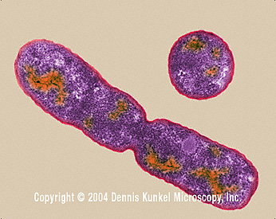

**Types of bacteria**

1. Rod shaped bacteria (bacilli)
2. Spherical shaped bacteria(cocci)
3. Spiral shaped bacteria

**1. Rod shaped bacteria (bacilli)**

e.gbacillus anthraces for anthrax,salmonella typhi for typhoid

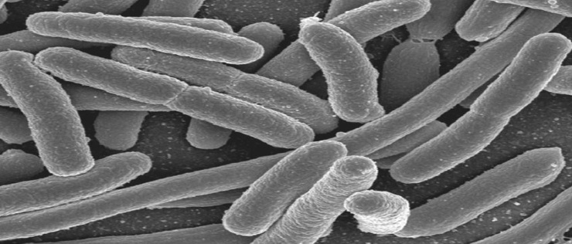

**2. Spherical shaped bacteria(cocci)**e.gstaphylococci for boils, streptococcus for sore throat, diplococci

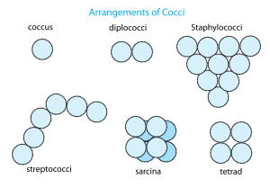

**3. spirochaete** for syphilis

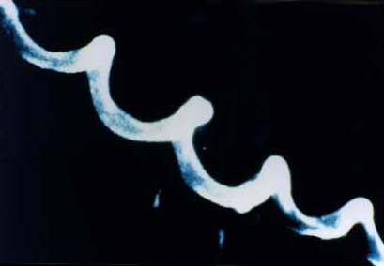

1. **Coma shaped bacteria(vibrios)**

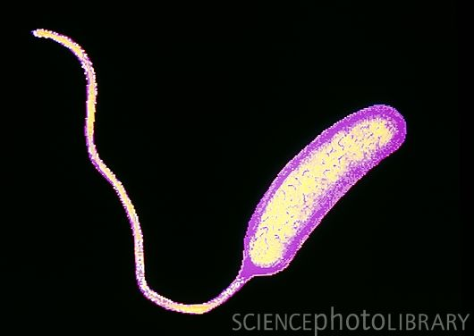

ACTIVITY

1. What are bacteria?
2. How do bacteria reproduce?
3. Identify one place where bacteria can be found.
4. In which way is reproduction in bacteria similar to that in fungi?
5. which type of bacteria course the following disease
6. Gonorrhea?
7. Syphilis?
8. Cholera?

**LESSON 5**

**Importance of useful bacteria**

1. Nitrogen fixing bacteria fix nitrogen back into the soil to improve soil fertility
2. Bacteria break or digestfibre food/ roughage / cellulose in the caeca of birds
3. Bacteria help in decomposition / rotting of dead plants and animals
4. Bacteria help too reduce on the amount of faeces in pit latrines as well as sewage tanks
5. Bacteria help in fermentation of beer, ghee, yoghurt and cheese.
6. Bacteria help in making humus (manure) in compost pits)
7. Bacteria help to reduce on the amount of garbage as they rot.

**Dangers of harmful bacteria**

1. Harmful bacteria cause diseases to both animals and plants.

2. Bacteria cause poor yields to crops

1. Bacteria cause food poisoning
2. contaminates food and makes it poisonous to human health
3. Some cause diseases.

**How to control dangers caused by harmful bacteria**

1. by preserving food(keeping food free from bacteria)
2. by observing proper food hygiene i.e. ensuring that food is kept in a clean environment and clean containers
3. by using antiseptics(drugs that kill germs on cuts and wounds)e.g. detol, saloon, hydrogen peroxide tincture of iodine etc
4. by sing disinfectants to kill bacteria in places like bacteria and reduce the bad smell e.g.harpic, jeyz , etc
5. by using antibiotic (drugs used to kill bacteria in our bodies) inform of injections, tablets, capsules, syrups e.g. penicillin from penicillium) that was discovered by Alexander Fleming, etc
6. through sterilization of medical instruments e/g springs
7. through pasteurization (involves) heating the food stuffs to ahigh temperature and sealing it before suddenly cooling it)

it was discovered by Dr. Louis Pasteur to preserve milk. He also discovered the vaccines against anthrax and rabies.

**LESSON 6**

**FUNGI**

Fungi are simple organisms that obtain their food from decaying plants and animal matter.

Fungi are saprophytes because they feed saprophytic ally (obtain soluble food from dead organic matter)

**Examples of fungi**

- Mushrooms

- Moulds

- Yeasts

- Puffball

- Toad stools (poisonous fungi)

**Characteristics of fungi**

- Fungi exist in both as single celled (unicellular) or multicellular organisms.

- Fungi lack chlorophyll (they can make their own food)

- Fungi feed saprophytic ally or parasitically

- They have nuclei in their cells

**Importance of fungi**

- Some fungi like yeast are used to bake bread and cakes

- Some fungi like mushrooms are a source of food to man

- Some fungi like moulds (penicillium rotatum) are used to make medicine penicillium

- Yeast is used to brew local beer or ferment fruit juices to make wine

- Fungi help in decomposition of rubbish in rubbish pits to make humus

- Yeast is used to flavors cheese

- Yeast is a source of vitamin B that prevents beriberi

**Mushrooms**

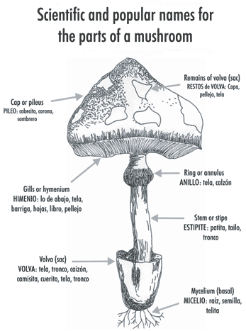

**IMPORTANCE OF MUSHROOMS.**

* They are eaten as food.
* Some mushrooms are sold to get money.
* Mushrooms are used for study purpose.

Activity

1. What are fungi?
2. How do fungi reproduce?
3. Give examples of fungi.
4. Draw a mushroom and name the cap, gills and stipe.

**WEEK 9**

**LESSON 1& 2**

**How do fungi reproduce?**

Most fungi reproduce by means of **spores** unlike Yeast which reproduces by **budding**

**Diagram**

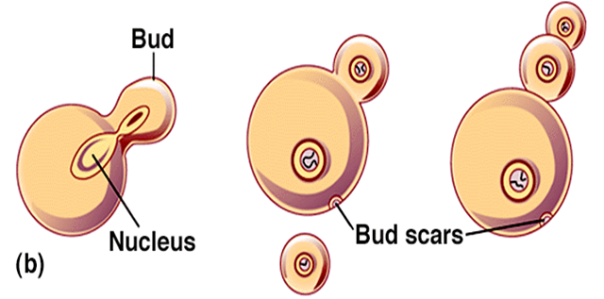

**Danger of harmful fungi**

- Harmful fungi cause food poisoning

- Harmful fungi cause a number of diseases to both plants and animals

**Examples of fungal diseases in animals**

- Ring worms (cause round patches on the skin)

- Athletes foot (attacks the skin between the hoes)

- Thrush caused by candida

- Finger nail deformation

**Examples of fungal diseases in plants**

- Panama e.g. banana

- Cigarand rot

- Blast wilt

- Coffee berry disease (rust) coffee plant

- Root rot in tea plants.

**How to control the dangers caused by harmful fungi**

- Boiling milk and water before drinking.

- Reheating and warming cold food before eating it.

- Salting the food.

- Pickling – putting vinegar in edible vegetables and other foods.

- Avoid eating uncovered food.

- Spray plants with fungicides.

- Get early treatment for any fungal infection /disease.

- Sterilize all surgical instruments to kill all the germs.

- Irradiation in canned foods.

- Avoid eating or catching poisonous fungi.

- Proper management of house refuse and rubbish

- Proper use of the latrine.

- Avoid sharing towels, socks, under wears etc.

- Use medicated soap to bathe e.g. detol,protex, etc.

- Use disinfectants in cleaning toilets e.g. jeyz.

**Similarities between bacteria and fungi**

- Both feed saprophytic ally

- Both cause fermentation

- Both can cause rotting /decomposition

- Some of them cause diseases while others are useful to man

- Some are single celled while others are multicellular

**Differences between bacteria and fungi**

- Bacteria reproduce by means of cell division (binary fission) while fungi reproduce by means of budding and spores.

- All bacteria are very tiny microscope while some fungi like mushrooms are big

- Bacteria reproduce much faster than fungi

- Some bacteria make their own food by combing some simple chemical substance while fungi cannot make their own food

**Topical questions**

1. How are bacteria different from fungi?

2. Where are bacteria found in our environment?

3. Name any one poisonous fungi

4. Give the three types of bacteria

5. Which bacteria do the following?

a) Add nitrogen back into the soil

b) Make food go bad

c) Cause typhoid

d) Cause cholera

6 Identify any two immunisable disease caused by bacteria

7 How do the following reproduce?

a) Yeast

b) Bacteria

8 Give the importance of fungi to people

9 How are bacteria useful to people?

10 In the space below, draw a mushroom and label all the parts

**LESSON 3 & 4**

**Mixture**

A mixture is when two or more different substance are mixed together e.g. when we mix sand and cement we get concrete blocks

**Dissolving substance/ solutes.**

These are substances that dissolve when put in water/ any liquid after stirring.

So, solutes are soluble in water or the liquid

**Examples of solutes.**

- Sugar

- Salt

-milk powder

**Insoluble substances.**

Substances which don’t completely dissolve in any liquid or water.

**e.g.** sand, maize flour, stones etc

**A suspension:**is a substance where the solute does not completely dissolve in the solvent.

**Solvent.**

Is a substance in which a solute dissolves.

**Examples.**

* water
* petrol
* methylated spirit

**Nb**:Water is universal solvent because it dissolves almost all solutes.

**solution.**

Is a uniform mixture of a solute and solvent.

**saturated solution** is a solution which dissolves more solutes after heating it.

**Super saturated solution** is a solution which cannot dissolve any more solute even offer heating it.

**SEPARATION OF MIXTURES.**

**a) Filtration.**

It is a process of separating solid particles from a liquid using a filter.

The solid particles that remain in the filter are called **residues.**

The liquid that passes through is called **a filtrate.**

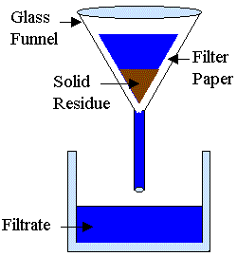

**How filtration method can be applied in our homes.**

* 1. When separating passion, orange, etc fruit juice from the seeds.
  2. When separating clear water from muddy water.

**LESSON 5**

**2. Decantation.**

It is when solids particles are allowed to settle at the bottom of a liquid then a liquid is carefully poured off to separate it from the solid particles.

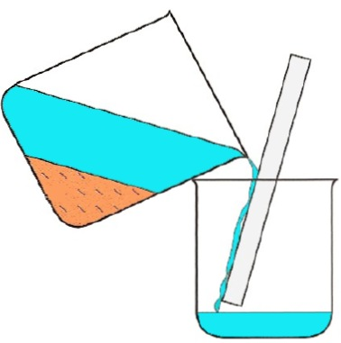

The solid particles that remain in the one container is called a **residue.**

The liquid that is collected in another container is called a **decantee.**

**How decantation method can be applied in our homes.**

1. When separating passion, orange, etc fruit juice from the seeds.

* 1. When separating clear water from muddy water.

**Qn:** Why is it important for one to first shake a syrup before taking it?

**For the medicine to mix with the liquid that has settled at the top.**

**LESSON 6**

1. **Distillation.**

It is the making of dirty water pure by evaporation and condensation.

**Nb:** Distilled water is not good for drinking because it lacks mineral salts.

The substance that remains in the container is called **a residue.**

The substance that is collected in the second container is called **a distillate.**

**Distilled water** is used to mix drugs in hospitals.

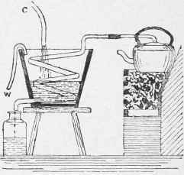

Experiment on how to separate mixtures.

**SEPARATION OF MIXTURES OF SOLIDS.**

1. Floatation.

It is a method of separation of mixtures where one sinks and the other floats.

1. Using magnets to separate metallic objects from non metallic objects.
2. Hand picking / sorting.